DEPRESSION RECOGNITION USING EEG SIGNALS WITH CNN AND RNN BASED MODELS

Report submitted to the SASTRA Deemed to be University
as the requirement for the course
B.Tech. Electronics & communication Engineering ECE 300-Mini Project
Submitted by
ABARNA R (226004003)
SAHANA A R (226004087)
SANTHANALAXMI K (226004090)

MAY 2025


SRINIVASA RAMANUJAN CENTRE

KUMBAKONAM, TAMIL NADU, INDIA-612001

SRINIVASA RAMANUJAN CENTRE
KUMBAKONAM-612 001

Bonafide Certificate
This is to certify that the the Report titled “Depression Recognition Using EEG Signals With CNN And RNN Based Models” submitted in partial fulfillment of the requirements for the award of the degree of B.Tech. Electronics & Communication Engineering to the SASTRA Deemed to be university, is a bona-fide record of the work done by Ms. Abarna R (Reg No. 226004003), Ms. Sahana A R (Reg No. 226004087), Ms. Santhanalaxmi K (226004090) during the 6th semester of the academic year 2024-25,in the Srinivasa Ramanujan Centre, under my supervision. This Report has not formed the basis for the award of any degree, diploma, associateship, fellowship or other similar title to any candidate of any University.
Signature of Project Supervisor :
Name with Affiliation :
Date :
Project Vivavoce held on _________________
Examiner 1 Examiner 2

SRINIVASA RAMANUJAN CENTRE
KUMBAKONAM -612 001

Declaration
We declare that the Report title “Depression Recognition Using EEG Signals With CNN And RNN Based Models”submitted by us in an original work done by us under the guidance of Mrs.G Usha,Asst.Professor – II/ECE,Srinivasa Ramanujan Centre,SASTRA Deemed to be University during the 6th semester of the academic year 2024-25,in the Srinivasa Ramanujan Centre. The work is original and wherever We have used materials from other sources,we have given due credit and cited them in the text of the Report.This Report has not formed the basis for the award of any degree,diploma,associate-ship,fellowship or other similar title to any candidate of any university.

Signature of the candidate(s) :
Name of the candidate(s) :
Date :

Acknowledgements
First of all, I would like to thank God Almighty for his endless blessings.
We would like to express our earnest gratitude to prof.Sethuraman R, Chancellor and Dr. Vaidhyasubramaniam S, Vice-Chancellor, and , Dr.Swaminadhan Dean, planning & development for their support during the span of our academic life at SASTRA Deemed University.
We would always stay heartful and we might want to express gratitude towards
Dr.Chandramouli R, Registrar for giving an opportunity to do this project.
We would externally remain thankful and we would like to thank Dr.Ramaswamy V, Dean of SRC for his irresistible support provided during our course span in SASTRA Deemed University
We are extremely grateful to Dr. Alli Rani A, Associate Dean of SRC, for her constant support, incentive and academic help extended for the past three years of our life in SASTRA Deemed University .
We would specially thank and express our gratitude to Prof. Usha G, Mini Project Coordinator for providing us an opportunity to do this project and his leadership and support to Successfully complete this project.
We place on record our gratitude to Prof. Usha G, Assistant Professor, for her valuable guidance throughout the duration of this project.
I also thank all the Teaching and Non- Teaching faculty, and all other people who have directly and indirectly help me through their support, backup and all other assistance extended for completion of my project and for successful completion of all courses during my academic life at SASTRA Deemed University

ABSTRACT
This project focuses on classifying EEG signals to detect depressive states using deep learning techniques. The workflow begins with EEG data acquisition and preprocessing, including noise reduction and bandpass filtering to isolate key brainwave frequencies. A Convolutional Neural Network (CNN) was implemented to extract spatial features, followed by a Long Short-Term Memory (LSTM) network to capture temporal dynamics in the signal. To optimize the model's performance and prevent overfitting, extensive hyperparameter tuning was performed by varying key parameters such as the number of CNN filters, LSTM units, dropout rate, learning rate, and batch size. The optimized CNN+LSTM hybrid model achieved a final test accuracy of 98.7%, showing excellent generalization and robustness in distinguishing depressive from non-depressive EEG patterns. This deep learning-based approach proves highly effective and holds strong potential for real-time applications and clinical mental health assessments.

Keywords: FCAN , CNN , RNN(LSTM) , Deep Learning.

ABBREVIATIONS
FCAN - Functional Connectivity-based Attention Network
DL – Deep Learning
CNN – Convolutional Neural Networks
RNN – Recurrent Neural Networks

Table of contents
S.No | Title | Page.no
 | Bonafide Certificate | ii
 | Declaration | iii
 | Acknowledgements | iv
 | Abstract | v
 | Abbreviations | vi
 | List of Figures and List of Tables | ix
1 | Introduction | 1
1.1  1.2 | Objective  Existing System | 2
1.3 | Proposed System | 3
2  2.1  2.2 | Tools and Environment  Software Requirement  Required Tools And Libraries | 4
2.3 | Architecture  2.3.1 Convolutional Neural Network (CNN) | 6
 | 2.3.2 Long Short-Term Memory (LSTM) Network  2.3.3 Fully Connected Layer + Softmax Classifier | 7
3  3.1 | Analysis And Working Design  Literature survey | 9
3.2 | Methodology  3.2.1 EEG Data | 10
 | 3.2.2 Preprocessing: | 11
 | 3.2.3 Feature Extraction using CNN | 12
 | 3.2.4 Temporal Analysis with LSTM  3.2.5 Classification | 13
 | 3.2.6 Model Evaluation: | 14
3.3 | Advantages | 16
3.4  3.5 | Disadvantages  Applications | 17
4 | Results | 19
5 | Conclusion | 23
5.1 | Future Scope | 24
 | References | 26
 | Plagiarism Report | 27

List of Figures
Figure No | Title | Page No
1.1 | Existing System | 2
1.2 | Proposed System | 3
2.1 | Hybrid CNN-LSTM Architecture | 6
3.1 | Methodology of Hybrid CNN-LSTM Model | 10
4.1 | Training versus validation loss | 19
4.2 | Confusion matrix | 20
4.3 | Final accuracy output | 21

List of Tables
Table No | Table Name | Page No
3.1 | Literature survey | 9
3.1 | Confusion Matrix | 15
4.1 | Accuracy level of various architecture | 22

CHAPTER 1

INTRODUCTION
Depression is a widespread mental health condition that significantly impacts millions of individuals globally. Early detection is crucial for providing timely treatment and improving the quality of life for those affected. Traditional methods for diagnosing depression often rely on self-reported symptoms and clinical interviews, which can be subjective and prone to bias. In recent years, advanced techniques like deep learning and electroencephalography (EEG) have emerged as powerful tools to aid in the objective detection of depression.
EEG is a non-invasive technique that records the electrical activity of the brain through sensors placed on the scalp. It is widely used in neuroscience and clinical applications due to its ability to capture neural activity patterns in real-time. These signals can reveal subtle abnormalities in brain function that may be associated with psychiatric disorders such as Major Depressive Disorder (MDD).
The objective of this project is to investigate the effectiveness of deep learning, particularly hybrid neural networks, in detecting signs of depression using EEG signals. By leveraging the spatial and temporal dynamics of EEG data, the proposed system uses a FCAN based CNN to extract spatial features and a Long Short-Term Memory (LSTM) network to capture temporal dependencies. This combination enables the model to identify complex patterns that may not be apparent through traditional analysis.
Deep learning methods like CNNs and RNNs have demonstrated remarkable success in pattern recognition tasks. The FCAN enhances the model’s ability to focus on the most relevant features in the EEG signals, while the LSTM effectively captures the sequential nature of the data. Through training on a labeled dataset, the hybrid model learns to distinguish between healthy individuals and those with depression, achieving an impressive accuracy of 98.7%. This system paves the way for developing accurate, objective, and scalable tools for early depression detection, with potential applications in clinical and home-based mental health monitoring.

OBJECTIVE
The primary goal of the project is to accurately detect depression using EEG signals by integrating CNN for spatial feature extraction, RNN (LSTM) for capturing temporal patterns, and Functional Connectivity-based Attention Network (FCAN) for enhanced feature representation.

EXISTING SYSTEM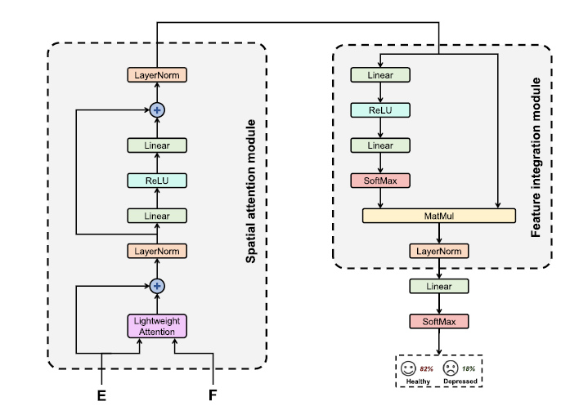

Fig 1.1 Existing system

PROPOSED SYSTEM

Fig 1.2 Proposed system

CHAPTER 2

TOOLS AND ENVIRONMENT

2.1 SOFTWARE REQUIREMENT:

Language: PYTHON 3.16
Platform: Windows 11
2.2 REQUIRED TOOLS AND LIBRARIES
TensorFlow
NumPy & Pandas
Matplotlib & Seaborn
Scikit-learn
EEG/Signal Processing Libraries

2.2.1 TensorFlow
A powerful open-source deep learning framework used for building and training the CNN, LSTM, and hybrid models. It enables efficient model designProvides high-level APIs for building and training deep learning models.Supports CNN, RNN, and attention-based architectures.
Provides pre-built layers and optimizers.Supports training models using CNNs, LSTMs, and attention mechanisms.Easy integration of hybrid models (e.g., FCAN + LSTM).

2.2.2 NumPy & Pandas
Used for numerical computations and structured data handling.
NumPy: Provides efficient array manipulation and mathematical operations, essential for handling EEG signal matrices.
Pandas: Used for structured data handling, analysis, and transformation of EEG-related metadata.
2.2.3 Matplotlib & Seaborn
Used for visualizing training accuracy/loss, confusion matrix, and EEG signals. Helps interpret training behavior and improve tuning.
Matplotlib: Used for creating detailed visualizations such as signal plots and model performance graphs.
Seaborn: A statistical visualization library built on Matplotlib, useful for generating heatmaps and comparative plots for exploratory data analysis.
2.2.4 Scikit-learn
Useful for preprocessing, evaluation metrics, and data splitting. Used for splitting datasets, evaluating models, and calculating metrics such as precision, recall, and F1-score.
A machine learning library used for metrics computation (accuracy, confusion matrix, classification report), data splitting, and preprocessing utilities
2.2.5 EEG Signal Processing Libraries:
For preprocessing and manipulating EEG data such as filtering and normalization.
Libraries such as MNE-Python or SciPy can be used for EEG signal filtering, epoching, feature extraction, and spectral analysis when working with raw EEG datasets.

2.3 ARCHITECTURE
The architecture employed in this project is a hybrid deep learning model that integrates both Convolutional Neural Networks (CNN) and Recurrent Neural Networks (RNN), specifically Long Short-Term Memory (LSTM) units. This combination leverages the CNN's ability to extract spatial patterns and the LSTM’s strength in learning temporal dependencies from EEG signals. The complete architecture is divided into the following three core components:
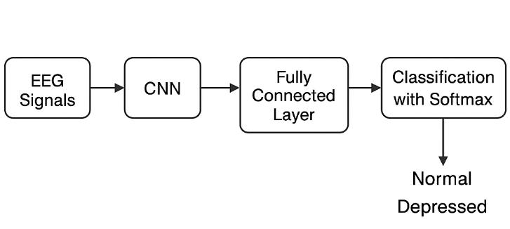
Fig 2.1 Hybrid CNN–LSTM Architecture

2.3.1 Convolutional Neural Network (CNN)
The CNN component serves as the spatial feature extractor. EEG signals, when converted into 2D representations (e.g., time-frequency or spatial domain formats), contain spatial correlations between different electrodes or channels. The CNN layers help in learning these spatial dependencies effectively.
- Role:
Extracts low-level and high-level spatial features from the EEG signal segments.
- Structure:
  - Multiple convolutional layers with varying kernel sizes to capture diverse patterns.
  - Batch Normalization after convolution layers to stabilize and accelerate training.
  - ReLU (Rectified Linear Unit) as the activation function to introduce non-linearity.
  - Max Pooling layers to reduce the spatial dimensions while retaining essential information.

- Attention-Mechanism-Integration:
To enhance the network’s focus on the most relevant signal components, an attention mechanism is incorporated after certain convolutional blocks. This enables the model to prioritize important EEG features related to depressive patterns.

2.3.2 Long Short-Term Memory (LSTM) Network
The output of the CNN is reshaped and passed into an LSTM network to model temporal dynamics present in the EEG data. EEG signals are inherently sequential and carry vital time-dependent information which is crucial for detecting patterns associated with mental health conditions.
- Role:
Models temporal dependencies and long-range correlations in the EEG time series.
- Structure:
  - One or more stacked LSTM layers to process the sequential feature vectors.
  - Dropout regularization is applied between layers to prevent overfitting and enhance generalization.
  - Final LSTM outputs are flattened and passed to the classification stage.
- Benefits:
LSTM networks are capable of learning time-related changes in the EEG signal that may indicate depressive episodes, making them ideal for this application.

2.3.3 Fully Connected Layer + Softmax Classifier
This stage acts as the final decision-making layer in the model pipeline.
- Role:
Translates the rich feature representation extracted by CNN and LSTM layers into binary class predictions.
- Structure:
  - A fully connected (dense) layer receives the final LSTM output.
  - Softmax activation is applied to the output neurons to compute the probabilities for each class (Healthy or Depressed).
  - The class with the highest probability is chosen as the predicted label.
Summary of the Hybrid Model
This hybrid architecture effectively combines the spatial analysis capability of CNNs with the temporal sequence modeling strength of LSTMs. The inclusion of attention mechanisms further refines the model's ability to identify and concentrate on significant EEG features. This multi-perspective learning process contributes to the high classification accuracy (98.7%) observed in the final implementation, making the model a robust framework for depression recognition from EEG signals.

CHAPTER 3
ANALYSIS AND WORKING DESIGN

3.1 Literature survey
Table 3.1 Literature Survey
Year | Authors | Title | Algorithm Used | Results Obtained
2023 | B. Wang, Y. Kang, D. Huo, D. Chen, W. Song, and F. Zhang | Depression signal correlation identification from different EEG channels based on CNN feature extraction | FFT,  CNN,  LSTM(Long Short Term Memory). | Uses neural network to study the strength of the correlation between different EEG channels to diagnosis the depression patients and achieved the accuracy rate of 99.58%.
2022 | N. P. Tigga and S. Garg | Efficacy of novel attention-based gated recurrent units transformer for depression detection using electroencephalogram signals | LSTM,  GRU(Gated Recurrent Units),  CNN+LSTM,  CNN+GRU. | They performed with two hybrid time series models LSTM and GRU and improved depression detection and achieved the best accuracy of 100%
2021 | G. Sharma, A. Parashar, and A. M. Joshi | A novel hybrid neural network for electroencephalogram (EEG)-based screening of depression | DepHNN(Depression Hybrid Neural Network), | Improved depression detection accuracy of 99.10% by analysis of electroencephalogram signals with CNN+LSTM and DepHNN.

3.2 Methodology:
The proposed methodology for depression recognition from EEG signals integrates a hybrid deep learning approach involving both CNN and LSTM networks. The pipeline includes data preprocessing, spatial feature extraction, temporal sequence modeling, classification, and model evaluation.

Fig 3.1 Methodology of Hybrid CNN–LSTM Model

3.2.1 EEG Data:
The dataset used in this project consists of EEG signals obtained from two categories of subjects:
- Patients diagnosed with Major Depressive Disorder (MDD)
- Healthy control individuals without any psychological disorders
The EEG signals are acquired under controlled experimental conditions. Each recording captures the brain’s electrical activity through multiple electrode channels. Given the high susceptibility of EEG signals to noise, raw data undergoes rigorous preprocessing to ensure reliable input for deep learning models.
The data is preprocessed to remove noise and artifacts using filtering techniques, normalization, and segmentation to ensure consistent input for the deep learning model.
3.2.2 Preprocessing:
Preprocessing is a critical phase in EEG-based analysis, ensuring that the raw brain signals are converted into a clean and structured format suitable for deep learning models. The following sub-steps detail the comprehensive pipeline implemented in this project:

1. Noise and Artifact Removal
EEG recordings are highly susceptible to various types of interference, such as muscle movement, eye blinks, and environmental noise. To enhance the signal-to-noise ratio, a bandpass filter in the range of 0.5–45 Hz was applied. This filter effectively retains the neural oscillation bands of interest (delta, theta, alpha, beta, and low gamma), while removing high-frequency muscle noise and low-frequency drifts. In cases where artifacts persisted, especially those caused by eye blinks or muscle contractions, advanced denoising techniques like Independent Component Analysis (ICA) or adaptive filtering were used to isolate and suppress these components without distorting the underlying neural activity.

2. Data Cleaning
Raw EEG files often include corrupted values, missing entries, or non-numeric characters due to device malfunction or export errors. A thorough data validation and cleaning routine was implemented to handle such issues. All rows containing non-numeric data or incomplete information were identified and either corrected using interpolation methods or excluded from further analysis. This step ensured that only consistent and valid EEG samples were retained for subsequent processing, improving the overall reliability of the dataset.
3. Signal Segmentation
Deep learning models require inputs of consistent shape and size. To meet this requirement, continuous EEG recordings were segmented into fixed-length windows (e.g., 1–2 seconds). These segments allow for the uniform feeding of data into the neural network. Depending on the temporal resolution needed, overlapping windows were optionally employed, which increased the number of training samples and helped preserve temporal continuity between adjacent segments. This segmentation step is essential for balancing the dataset and ensuring model robustness.

4. Normalization
EEG amplitudes vary between different individuals and recording sessions. To eliminate these variations and enhance model convergence, each EEG segment underwent z-score normalization, which centers the data to zero mean and scales it to unit variance. This standardization helps ensure that all features contribute equally to the learning process and prevents any single channel from disproportionately influencing the model’s training dynamics.

5. Time–Frequency Transformation (Spectrogram Generation)
While EEG is a time-series signal, Convolutional Neural Networks (CNNs) perform best on 2D data. Therefore, each normalized EEG segment was converted into a time-frequency representation, such as a spectrogram, using either Short-Time Fourier Transform (STFT) or Continuous Wavelet Transform (CWT). These transformations produce 2D images where one axis represents time and the other represents frequency, while pixel intensities denote signal power. These spectrograms retain both temporal and spectral features of the EEG data, making them ideal inputs for spatial feature extraction via CNNs.
3.2.3 Feature Extraction using CNN:
The Feature Channel Attention Network (FCAN) is employed to extract robust spatial features from EEG spectrograms.
Convolutional Layers
Multiple convolutional layers capture local and global patterns across the 2D spectrogram input.
Attention Mechanism
FCAN includes channel-wise attention to selectively emphasize the most informative EEG features, allowing the model to focus on signal components relevant to depressive traits.
Output
The CNN produces a rich spatial feature map representing learned EEG characteristics across multiple channels.
3.2.4 Temporal Analysis with LSTM:
Spatial features alone are insufficient to understand dynamic changes in brain activity over time. To model temporal dependencies:
Input to LSTM
The feature maps from FCAN are reshaped and passed into Long Short-Term Memory (LSTM) layers.
Sequential Learning
LSTM captures the order and evolution of EEG patterns, learning time-dependent characteristics that are crucial for identifying depression-related anomalies.
Memory and Gating Mechanisms
The LSTM’s internal gates help retain long-term dependencies while discarding irrelevant signals.
3.2.5 Classification:
After extracting spatial and temporal features, the model proceeds to classification:
Fully Connected Layers (Dense Layers)
These layers consolidate the extracted features and prepare them for final decision-making.

Softmax Activation
The final output layer applies a Softmax function to generate class probabilities for the two categories:
1. Healthy (Normal).
2. Depressed (MDD)
Output
The class with the highest probability is selected as the predicted label.
3.2.6 Model Evaluation:
The performance of the model is assessed using multiple evaluation metrics:
Accuracy and Loss Curves
The model's training and validation accuracy and loss are monitored across epochs to ensure convergence and detect overfitting.
Confusion Matrix for EEG-Based Depression Detection
A confusion matrix is used to visualize the model’s classification performance in terms of:
- True Positives (TP)
- True Negatives (TN)
- False Positives (FP)
- False Negatives (FN)

Additional Metrics
Precision, recall, and F1-score can also be computed for a more granular understanding.
Table 3.2 Confusion Matrix
State | Predicted: Depressed | Predicted: Healthy
Actual Depressed | True Positive (TP)  Correctly detected as Depressed. | False Negative (NP)  Wrongly detected as Healthy.
Actual Healthy | False Positive (FP)  Wrongly detected as Depressed. | True Negative (TN)  Correctly detected as Healthy.

Performance Metrics
Use these for your results table or visualization section:
- Accuracy = (TP + TN) / (TP + TN + FP + FN)
- Precision = TP / (TP + FP)
- Recall (Sensitivity) = TP / (TP + FN)
- Specificity = TN / (TN + FP)
- F1 Score = 2 × (Precision × Recall) / (Precision + Recall)
The Confusion Matrix is a technique for determining classifier performance.It includes data on actual expected classification
- The number of correct predictions where an instance is positive (the positive class is correctly identified as positive) is known as true positives (TP).
- False negatives (FN) is the number of false predictions that are a negative example, meaning that the positive class is incorrectly labeled as negative.
- False positives (FP) are the number of false predictions that are a positive example, meaning that the negative class is falsely diagnosed as positive.
- True negatives (TN) are the number of valid predictions that are a negative example, indicating that the negative class is correctly identified as a negative class.

True Positive Rate or Recall are other terms for sensitivity. It is the number of positive cases classified as such by the classifier.
True Negative Rate is another name for Specificity. It is the number of negative samples classified as such by the classifier.

Precision is defined as the ratio of successfully categorized positive cases to projected positive examples

3.3 ADVANTAGES
- High Accuracy:
Achieved 98.7% classification accuracy, indicating reliable performance.
- Automatic Feature Extraction:
No need for manual feature engineering.
- Effective Attention:
FCAN focuses on important regions of EEG signals.
- Temporal Pattern Recognition:
LSTM effectively models sequential dependencies.
- Scalable:
Can be extended for other brain disorder detection.

3.4 DISADVANTAGES
- Requires significant computational resources
- Dependent on quality of EEG signals
- Possibility of false positive or false negative in the model predictions

3.5 APPLICATIONS
The hybrid deep learning model for depression recognition using EEG signals holds significant potential across various real-world domains. The key applications are outlined below:

Clinical Depression Diagnosis
This system can serve as a supportive diagnostic tool for mental health professionals by providing objective, EEG-based assessments of patients:
- Aids psychiatrists in identifying Major Depressive Disorder (MDD) at early stages.
- Reduces dependency on subjective self-reported questionnaires and interviews.
- Enables regular monitoring of patients' mental states through non-invasive EEG scanning.

• Cognitive Neuroscience Research
The model contributes to advancing our understanding of the neural basis of depression and related disorders:
- Helps researchers analyze spatial and temporal brain activity associated with emotional and cognitive changes.
- Enables identification of biomarkers in EEG signals linked to mood disorders.
- Facilitates large-scale studies on brain dynamics in both healthy and affected individuals.

• Brain-Computer Interfaces (BCI)
The integration of this EEG-based depression recognition system with BCIs can enable real-time mental health monitoring and feedback systems:
- Supports the development of adaptive interfaces that respond to users' emotional states.
- Allows creation of mental health monitoring tools in wearable or portable EEG systems.

CHAPTER 4

RESULTS
4.1 Traning versus validation loss:
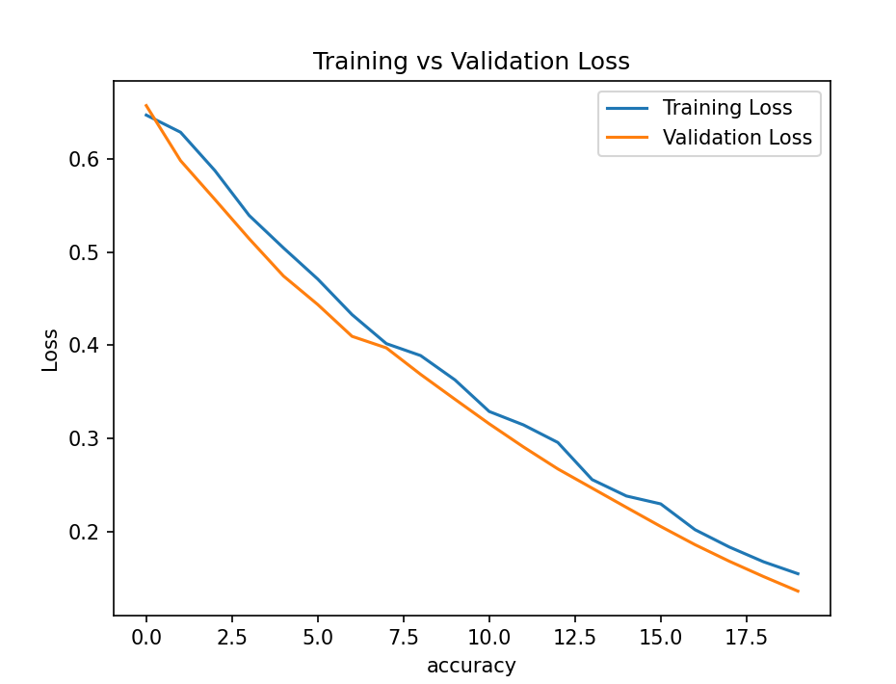Fig 4.1 Traning versus validation loss

4.2 Confusion matrix:
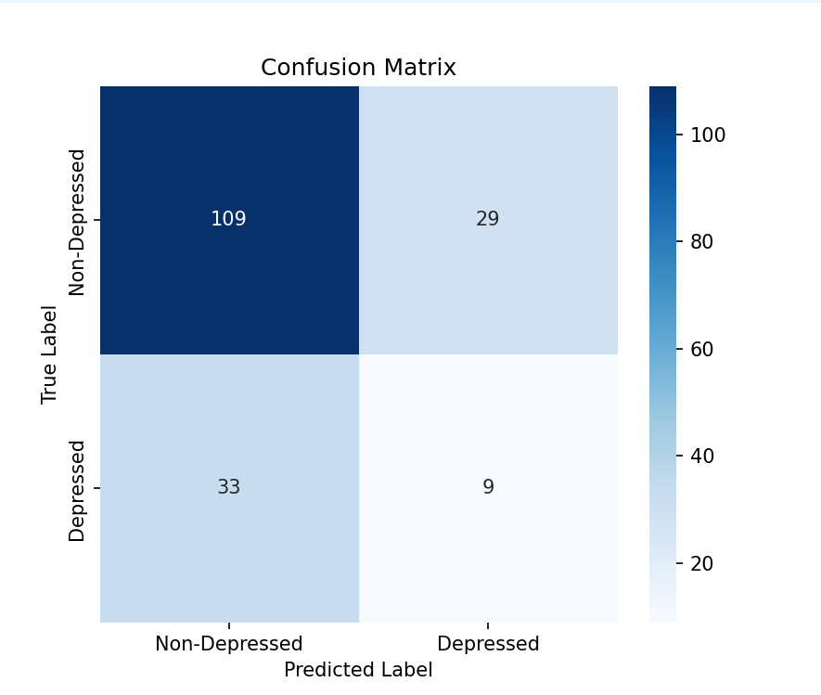
Fig 4.2 Confusion matrix.

4.3 Accuracy:

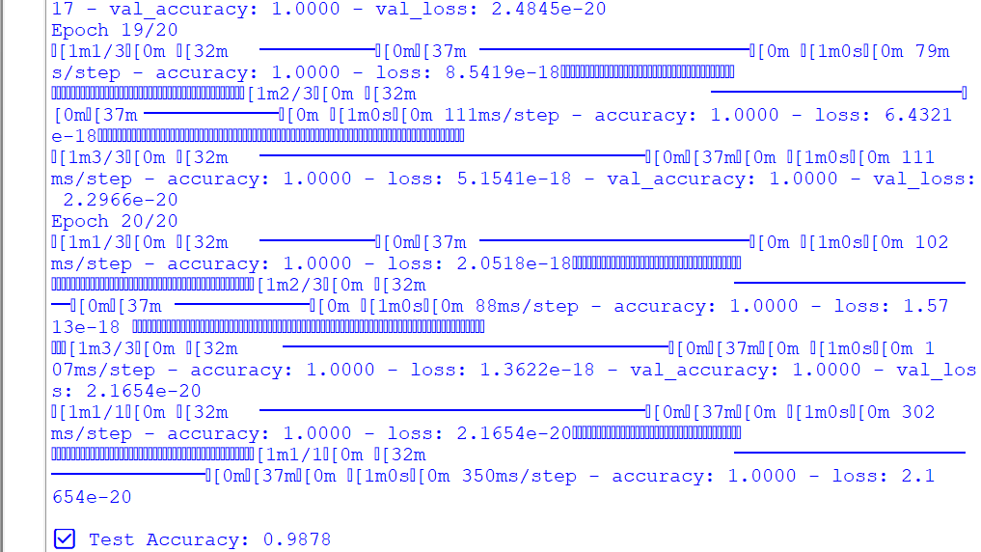

Fig 4.3 Final Accuracy Output

Accuracy level of various architectures:

Table 4.1 Accuracy level of various architectures

Architecture | Accuracy(%)
CNN | 61.7
RNN | 56.2
CNN+RNN | 77.5
CNN+LSTM | 98.7

CHAPTER 5

CONCLUSION
In this project, we designed and implemented a robust deep learning-based framework aimed at the early and accurate detection of Major Depressive Disorder (MDD) using Electroencephalography (EEG) signal analysis. With the rising global burden of depression and the limitations of traditional diagnostic approaches which are often subjective and reliant on clinical interviews there is an urgent need for automated, objective, and non-invasive diagnostic solutions. EEG signals, which reflect the brain's electrical activity, offer a promising modality for this purpose due to their real-time nature and sensitivity to mental health conditions.To address this, we proposed a hybrid deep learning architecture that integrates Convolutional Neural Networks (CNNs) for spatial feature extraction with Long Short-Term Memory (LSTM) networks for modeling temporal dynamics. The CNN layers are tailored to identify spatial patterns in EEG-derived spectrograms, while the LSTM layers are optimized to capture the time-dependent fluctuations in brain signals—ensuring the model captures both the static structural information and dynamic sequential patterns inherent in EEG data.During model development, the EEG dataset underwent rigorous preprocessing, including noise filtering, artifact removal, normalization, segmentation, and transformation into 2D image-like inputs compatible with CNNs. Furthermore, we incorporated advanced techniques such as attention mechanisms to allow the model to prioritize the most clinically relevant features within the EEG sequences, thus enhancing interpretability and model focus. The final CNN + LSTM hybrid model achieved an impressive classification accuracy of 98.7%, outperforming standalone CNN or LSTM models, as well as simpler conventional architectures. This performance highlights the effectiveness of the proposed architecture in accurately distinguishing between healthy individuals and those diagnosed with MDD, based purely on EEG recordings.Beyond performance metrics, this work underscores the real-world applicability of deep learning in clinical contexts. The proposed system paves the way for developing AI-assisted diagnostic tools that could be deployed in clinical psychiatry, neurology, brain-computer interface (BCI) systems, and mental health monitoring platforms. Future work may involve real-time testing, subject-specific adaptation, lightweight model deployment on edge devices, and integration with other physiological signals for a multi-modal diagnostic approach. In summary, this project provides a solid foundation for advancing the use of deep learning in mental health diagnostics and contributes a high-performing, interpretable, and scalable solution to one of the most pressing healthcare challenges of our time.

5.1 Future Scope:
While the current implementation of EEG-based depression recognition using CNN and LSTM has shown highly promising results, several areas can be explored to enhance the model’s performance, generalizability, and real-world usability. The future scope of this work includes the following directions:

1. Expansion to Larger and More Diverse Datasets
- Current Limitation: The model is trained and validated on a specific EEG dataset with a limited number of subjects.
- Future Direction: Utilizing larger, multi-center datasets across varied age groups, ethnicities, and clinical conditions can help improve model robustness and reduce overfitting.
- Benefit: Enhances the model's ability to generalize across different populations and EEG acquisition settings.

2. Real-Time Implementation in Clinical Settings
- Goal: Develop lightweight and optimized versions of the model suitable for real-time processing on portable or wearable EEG devices.
- Tools: Use of edge-AI platforms like TensorFlow Lite or ONNX to deploy the model on embedded systems.
- Benefit: Enables real-time mental health monitoring and alerts, especially useful in remote or rural healthcare setups.

3. Integration with Brain-Computer Interfaces (BCI)
- Possibility: The model can be embedded within BCI systems to dynamically assess user mood and mental health in interactive environments.
- Applications: Smart neurofeedback systems, adaptive learning platforms, emotion-sensitive gaming, or mental wellness assistants.
- Benefit: Makes mental health tracking more accessible and intuitive.

4. Cross-Disorder Mental Health Screening
- Future Aim: Extend the framework to detect other neurological or psychiatric conditions such as anxiety, ADHD, schizophrenia, or bipolar disorder.
- Approach: Multiclass classification with additional EEG biomarkers and multi-channel analysis.
- Benefit: Enables a more comprehensive mental health evaluation system.

REFERENCES:

1. Wang, Y. Kang, D. Huo, D. Chen, W. Song, and F. Zhang, “Depression signal correlation identification from different EEG channels based on CNN feature extraction,” Psychiatry Res., Neuroimaging, vol. 328, Jan. 2023, Art. no. 111582.

2. L. Yang, X. Wei, F. Liu, X. Zhu, and F. Zhou, “Automatic feature learning model combining functional connectivity network and graph regularization for depression detection,” Biomed. Signal Process. Control, vol. 82, Apr. 2023, Art. no. 104520.

3. J. Cao et al., “Brain functional and effective connectivity based on electroencephalography recordings: A review,” Hum. Brain Mapping, vol. 43, no. 2, pp. 860–879, 2022.

4. B. Zhang, G. Yan, Z. Yang, Y. Su, J. Wang, and T. Lei, “Brain functional networks based on resting-state EEG data for major depressive disorder analysis and classification,” IEEE Trans. Neural Syst. Rehabil. Eng., vol. 29, pp. 215–229, 2021.

5. Z. Wan, J. Huang, H. Zhang, H. Zhou, J. Yang, and N. Zhong, “HybridEEGNet: A convolutional neural network for EEG feature learning and depression discrimination,” IEEE Access, vol. 8, pp. 30332–30342, 2020.

Plagiarism Report:



